PRACTICAL 2
Part A (To be referred by students)

Conditional Statements & Strings
SAVE THE FILE AND UPLOAD AS (RollNo_Name_Exp2)
Aim: To Implement python programs to demonstrate different decision-making and Control Statements and string handling.

Problem Statement: Write Python program to
- Accept three sides of a triangle and print if the triangle is equilateral, isosceles or scalene.
- A function f is defined as follows :
f(x) = ax³ – bx² + cx –d, if x > k
= 0, if x = k
= -ax³ + bx² – cx +d, if x < k
Write a program that reads a, b, c, d, k and x and prints the value of f(x).
- Implement Body Mass Index calculator. Define BMI function to accept weight and height as parameter and displays appropriate BMI status.
BMI = weight(kg)/Height²
BM | Status
<= 18.4 | Underweight
18.5 – 24.9 | Normal
25.0 – 39.9 | Overweight
>=40 | Obese
- Implement distance convertor to convert distances by reading choice from user
  - inches to feet
  - cm to meter
- Write a program to read and display a string
- Create a string variable s with the value "Hello World" and print its length.
- Convert the string "Python Programming" to lowercase and print it.
- Concatenate the strings "Data" and "Science" with a space in between and print the result.
- Remove all leading and trailing whitespace from the string " Data Analysis " and print it.
- Define one string and display all elements at odd indexes using slicing operator
- Write a program to check entered string is palindrome or not.
- Reverse the string ‘Hello’ only using string slicing
- WAP to split the string into a list of words and then join them back into a single string with a user-defined delimiter.
- Write a python program to take a list of words, reverse the order of the words, and then join them into a single string with a hyphen - as the separator.

Topic covered: Conditional Statements (if, if…else, nested if, elif, pass and Strings, ),

Learning Objective: Learner would be able to
- Analyze the scenario to write script applying conditional statements.
- Infer the features of conditions for true and false decision-making.
- Solve the problems using decision-making statements
- Process string and perform various slicing operations on string
Theory:
- The if statement:
Syntax of if statement  if test_expression:  body of if  The program evaluates the test expression and will execute statement(s) only if the test expression is True.  If the test expression is False, the statement(s) is not executed.  In Python, the body of the if statement is indicated by the indentation. The body starts with an indentation and the first unindented line marks the end.  Python interprets non-zero values as True. None and 0 are interpreted as False. | 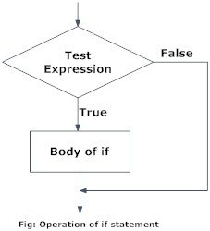
- The if…else statement:
Syntax of if…else statement  if test_expression:  body of if  The if..else statement evaluates test expression and will execute the body of if only when the test condition is True.  If the condition is False, the body of else is executed. Indentation is used to separate the blocks. | 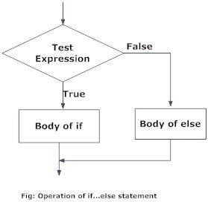

- The if…elif…else statement:
The if…elif…else statement is used for decision making.
Syntax of for Loop  if test_expression:  body of if  elif test_expression:  body of elif  else:  body of else  The elif is short for else if. It allows us to check for multiple expressions.  If the condition for if is False, it checks the condition of the next elif block and so on.  If all the conditions are False, the body of else is executed.  Only one block among the several if...elif...else blocks is executed according to the condition.  The if block can have only one else block. But it can have multiple elif blocks. | 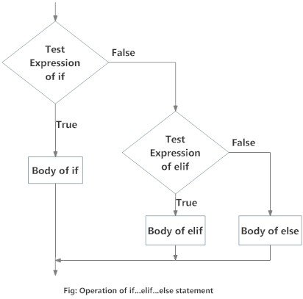

# Check if number is positive or negative or zero:
num = int(input("Enter a number "))
if num > 0:
print("Positive number")
elif num == 0:
print("Zero")
else:
print("Negative number")
Output:
Enter a number 2
Positive number

- The Nested if statement:
We can have a if...elif...else statement inside another if...elif...else statement. This is called nesting in computer programming.
Any number of these statements can be nested inside one another. Indentation is the only way to figure out the level of nesting.

# Check if number is positive or negative or zero:
num = int(input("Enter a number: "))
if num >= 0:
if num == 0:
print("Zero")
else:
print("Positive number")
else:
print("Negative number")
Output:
Enter a number: 0
Zero

String
- String literals in python are surrounded by either single quotation marks, or double quotation marks.
- 'hello' is the same as "hello".
- You can display a string literal with the print( ) function:
- Example
print("Hello")
print('Hello')
- Assigning a string to a variable is done with the variable name followed by an equal sign and the string:
- Example
a = "Hello"
print(a)
### Str --- String ###
name=u'\u092a\u0948\u0925\u0964\u0928'
print(name)

# Slicing operations on string [start:stop:stepsize], if start and stop is not specified it takes 0 and n-1 and if step size in not specified it is 1.

# slicing the string stringname[start:stop:stepsize]
str='core python'
print(str[0:9:1])

#str[0:9:2] --> stepsize 2
#str[2:4:1] --> 2 to 3 in size 1
#str[ : :2] --> access entire string in steps of 2.
#str[ :4: ] --> access string from 0 to 3 and stepsize is 1.
#str[-4:-1: ]--> access string from -4 to -2 from left to right
#str[-1:-4:-1]-> -1 to -3 from right to left...
#str[-1::-1] --> retrieves from last to first element [reverse]

#Repeating String...
print(4*"Python")

Concatenation (Joining)
s1="Core"
s2="Python"
s=s1+s2
print(s)

#Checking Membership
Write a program to find sub string in main string...
#operator:- in -- if found returns true ---And--- not in-- returns false if not found
str=input('Enter String')
sub=input('Enter sub string')
if sub in str:
print("Found")
else:
print("Not Found")

# Comparing String...
s1='Box'
s2="box"
if(s1==s2):
print("Same")
else:
print("Not Same")

PRACTICAL 2
Part B (to be completed by students)

Conditional Statements and Strings

- All the students are required to perform the given tasks in Jupyter Notebook
- Create a new notebook for each experiment. The filename should be RollNo_Name_Exp1)
- In the first cell, the student must write his/her Name, roll no and class in the form of comments
- Every program should be written in separate cells and in the given sequence
- After completing the experiment, download the notebook in pdf format. The filename should be RollNo_Name_Exp1.pdf).
- Upload the pdf on the web portal

